**Assignment – 19 Views.**

1. Create a view that shows all of the customers who have the highest ratings.

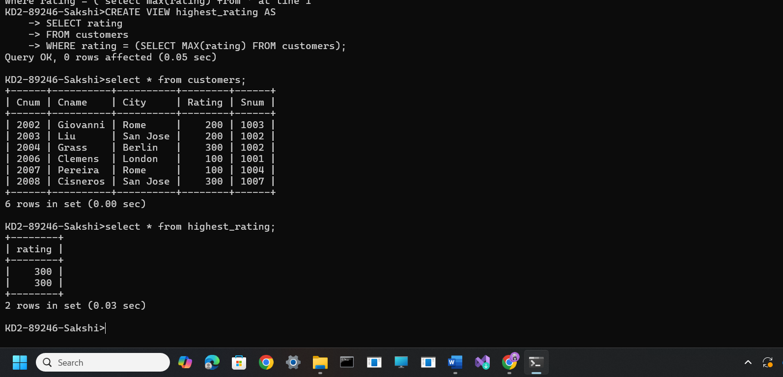

2) Create a view that shows the number of salespeople in each city.

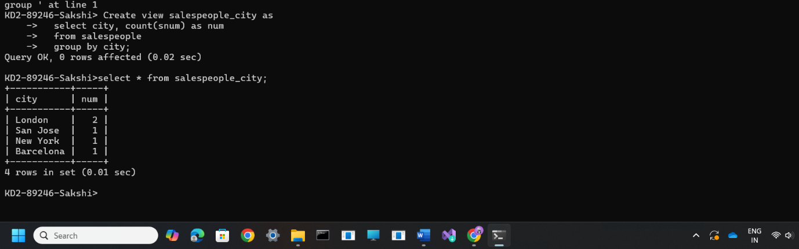

3) Create a view that shows the average and total orders for each salesperson after his or her name. Assume all names are unique.

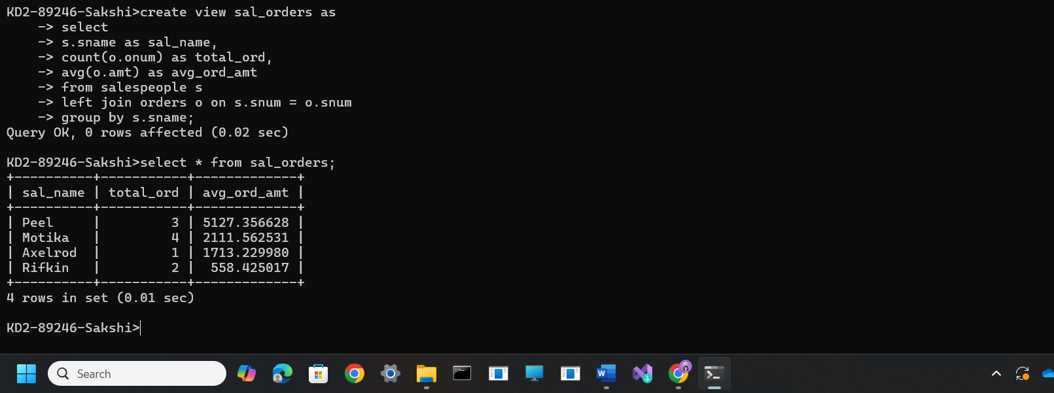

4) Create a view that shows each salesperson with multiple customers.

